

Coot’s Guide To Owning A Dachshund





A bit about dachshunds

The origins of the Dachshund can be traced back to working dogs that could go to ground after animals such as badgers, foxes and rabbits. The breed is described as moderately long and low with a well-muscled body, bold, defiant carriage of head and intelligent expression. Dachshunds are very popular as pets and, in the UK, come in six varieties, two sizes – Standard and Miniature – and three coats – Smooth, Long and Wire Haired. At coots we are specialised in miniature and standard smooth haired dachshunds.

Coats and colours

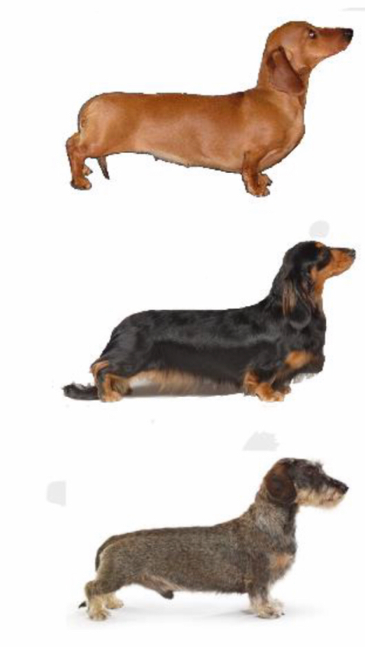**Smooth-haireds** are the “traditionally recognised” Dachshund. Their coats are dense, short, smooth and shiny, requiring little maintenance. Most common colours are Black and Tan, Red, Chocolate and Tan, and Dapple.

**Long-haired** coats are soft and straight with feathering on the underparts, ears, behind the legs and the tail where it forms a flag. Their coats require regular grooming. Most common colours are Black and Tan, Red (ranging from Cream to Shaded Red), Brindle (Tiger-striped), Chocolate and Tan, and Silver Dapple.

**Wire-haireds** are the “rugged workmen” and have a short, harsh coat with a dense undercoat. There is a beard on the chin, the eyebrows are bushy, but hair on the ears is almost smooth. Wire coat texture varies from “pin wire” (very harsh) to “hairy” (longer and

less harsh). A Wire coat typically will need stripping (never clipping) two or three times a year, depending on its texture. Most common colours are Wild Boar where the individual hairs are striped (also called Brindle in the UK) and Red. Chocolate and Tan, and Dapple also occurs.

Do not be talked into buying a “dilute coloured” Dachshund (Blue or Isabella). These dogs have a high risk of skin diseases such as Colour Dilution Alopecia and no reputable breeder would deliberately breed them.



Will a dachshund be the right breed for me and my family?

Dachshunds are active dogs and will take as much exercise as you can give them. They are, however, just as happy curled up on your lap, snoozing. They are loyal companions and make good family pets, but they can be noisy. They are not noted for their obedience but, with patience and persistence by the owner, they can be trained. However, they are Hounds and when they are off the lead, if they get a scent, they can “go deaf” when it suits them.

As a generalisation, Wires are the most extrovert and active, Longs are the most laid-back, and Smooths are perhaps more “one person” or “one family” dogs. All our coots sausages are fiercely loyal to our family members.

Standards are more robust and probably more suited to families with young children. All the Miniatures make ideal pets for someone who is perhaps less active and who wants a small but affectionate companion.

Health issues to be aware of

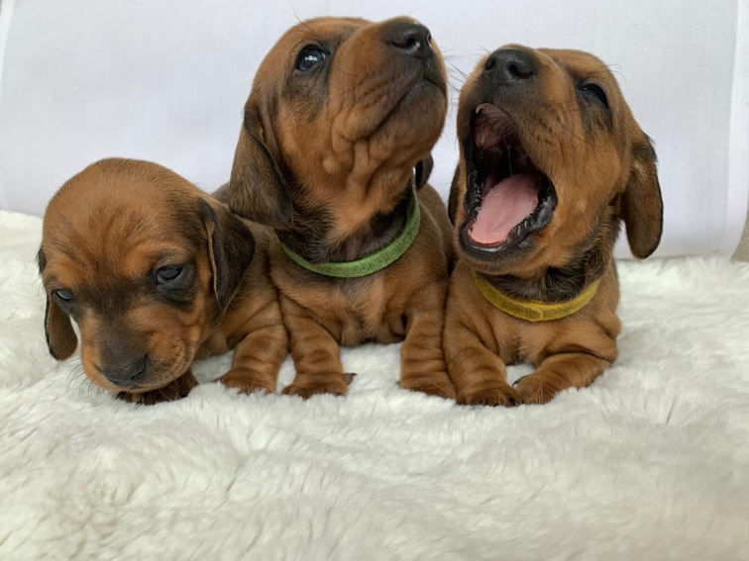Dachshunds generally suffer few health problems providing they are kept well exercised and fed a healthy, balanced diet. On average, they live to around 12 years old. Miniatures tend to live longer than Standards.

Because they are a dwarf breed there is an increased risk of back problems (IVDD). All coots breeding bitches and studs are tested for IVDD. Problems are best avoided by keeping the dog fit and not overweight, or to run up and down stairs which puts extra stress on the back. Early neutering also increases IVDD risk.

All coots breeding bitches and studs have been tested for retinal degeneration (cord 1 mutation PRA) which is an inherited condition causing degenerative disease of retina, resulting in visual in visual impairment or blindness.



Grooming

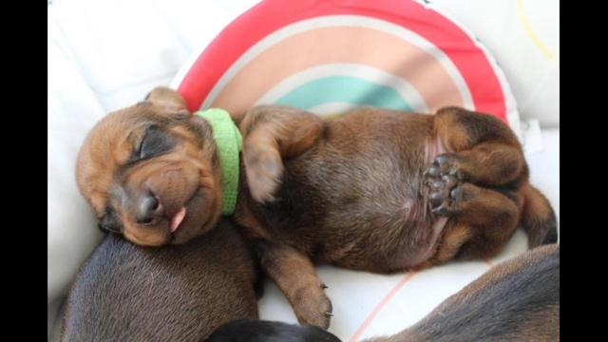

Once a week it’s good to check your dog's eyes, ears and feet. Keep the nails short using nail clippers, or a file. When your dog has all his adult teeth (by about 6 months) start brushing the teeth weekly. Coots sausages love this!

FAQs

**Q. Should I get a dog or a bitch?**

There is little difference in size or temperament between Dachshund dogs and bitches. Bitches do have the disadvantage of coming in season twice yearly. Dogs can be accused of having antisocial (leg-lifting) habits, but these usually only occur when a dog has been used at stud.

**Q. Are they easy to house-train?**

If you put the time in when your puppy is very young, then yes. You must be patient and consistent; never chastise but show the puppy the area to be used outside and praise when it is good.

**Q. Does my garden need to be dog-proof?**

Yes. All Dachshunds can dig! Your garden needs a good strong fence all round. Make sure all visitors shut any gates.



**Q. Do they come back if let off the lead?**

It depends!!! If you let them off the lead when they are young puppies (after they have completed their vaccinations), you can usually teach them to come back by use of encouraging commands and titbits as bribes. However, some dogs have a very strong hunting instinct and may never be safe to let off. The secret is to start young and make it fun for them to come back. They have absolutely no road sense and however well-trained your Dachshund may be, it is simply not worth the risk (and potential heartbreak) to let it walk near a road, off the lead. Near a road, always keep your dog on a short lead; never use an extending flexi-lead.

**Q. Do they bark a lot?**

In general, they are a noisy breed and they can become persistent barkers so you do have to work hard with them as puppies to ensure they know when to be quiet and how to behave around other dogs and people.

**Q. How much exercise do they need?**

A young puppy does not need any formal exercise; playing in the garden will be sufficient. A puppy needs lots of sleep, so allow it to go to bed whenever it wants to. Once the puppy has finished its course of inoculations, start to take it for a short walk of about 5 minutes every day to help it get used to traffic and other people and dogs. By the time it is about 4 months old, it should be

having a 20-minute walk every day, then as it gets to 5 months gradually increase the distance and time to about 25 minutes every day. By 6 months it should be going for a 30-minute walk each day. By a year old you should be giving your dog a 50-60 minute walk each day. An adult Dachshund will take any amount of exercise you care to give.